**Q. 1 Ceiling of a Number**

* smallest element in an array greater or equal to target no.
* I/P = {2, 3, 5 ,9 ,14, 16, 18} ---------------- target =14
* O/P = 14

APPROACH:

Same BS code instead of return -1; return start

**WHY?** because when the while loop condition gets violated i.e. (s<=e) the next big element greater or equal to target will be start itself.

EDGE CASE : what if the target is the greater than the greatest number in array

if(target > arr[arr.length() – 1] {

return -1;

}

**Q. 2 Floor of a Number**

* largest element in an array smaller or equal to target no.
* I/P = {2, 3, 4 ,9 ,14, 16, 18} ---------------- target =15
* O/P = 14

APPROACH:

Same BS code instead of return -1; return end

**WHY?** because when the while loop condition gets violated i.e. (s<=e) the next largest element smaller or equal to target will be start itself. 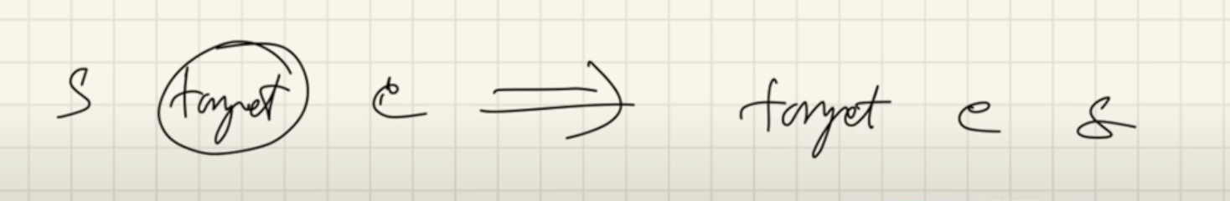

(ascending order mei agar dekho ) toh end will be largest element after target but smaller than start

